Source code management tool or version control tool :-

**By using this source code management tool or version control tool we** are storing entire code in centralized reposit

In this we can know about the when the developer modified you’r project ,and which modification he did in your project ,and which developer modified your project and commit the project ,and in which branch you pushed the project ,all this things we can know by using this source code management tool or version tool.

SVN AND CVS AND GIT AND GIT HUB this and all are source code management tool or version contro tools

But in this why we are preferring git ?

Because of git is the open source that is the main advantage in git version tool. And its having more features compare to SVN and other version tools.

SVN is the old version and GIT is the new version if want to compare.

*SVN is the centralized repository management.

*GIT Is a distributary repository management tool.

SVN:

Ex:just think in this svn is one repository,in this we have some developers,in this if developers wants to connect to repository,then the developers will directly login to the centralized repository in SVN by using credentials

After logged in to the centralized repository we can do developers side code modification or we can develop the code or we can do commits or merging.

*In SVN Developers are directly interact with centralized repository.after that they will Do modify the code or developing or merging the code

GIT:-

*GIT is a distributed repository management

*the developers are develop the code in local mission and modified the code and after developing the code they will push the code to the centralized repository.

SVN DISADVANTAGES:-

SVN:- while developers developing the code in centralized repository here we want network ,if network fails while developing the code in centralized repository the developers are cannot connect to the centralized repository and they cant develop the code.

This is the one of the disadvantage.

GIT ADVANTAGES :-

In GIT we are developing the code in our local missions and after developing ang modification we are pushing the project in centralized repository.

Donot want network while developing the code in local mission.

GIT Disadvantage:-

Network is wants While pushing the code into centralized repository,wecant push the code if we loss the network while pushing code to centralized repository.

GIT :-

In this having three phases,they are

1)Work Space Area

2)Staging or Index Area

3)Local Repository

What is the use of these three phses ?

First we have to know about GITHUB repository,

For EX:-In google drive we storing our data and after that we are downloading and uploading that data from different different locations.

Like that only GITHUB is the centralized repository,which is available in ‘Cloud’.

**Like that only we are storing the developed code in GITHUB(centralized repository).

**If we want to store the developed code in centralized repository we have to follow this three phases.

The process of this storing is

Work Space

Staging OR Index Area

Local Repository

GITHUB(centralized repository)

What is work space area ?

While developers creating files and developing code are stored in work space by default.

The stored files of work space we have to move the Staging or Index Area,Why because after that we cancommit to local repository, from there it will easily send to GITHUB(centralized repository)

What is the use of staging or index area?

When we get the code from work space after index area commit the code to local repository at that particular time it will store the total data of sender

EX: it will stores total data of sender

Who sending the code.

What is the user name of sender.

What is the mail id of sender.

In which time he moving the data

What is the particular message.

This total information will store while sending data from index area to local repository.

After that we can store the code in centralized repository (GITHUB).

But while seeing this process we can get a small doubt.

That doubt is

Where is located this three phases ?

Where we installed the GITHUB in that specification path these three phases are located.

HOW TO INSTALL GIT :--

1)Opengoogle and type web download



*it will show the download 2.22.0 click on download.

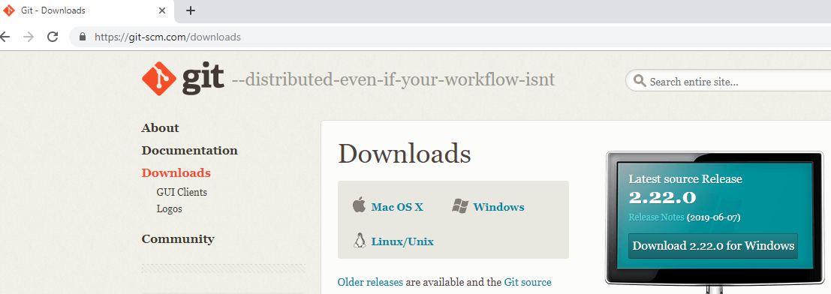

*Go to downloaded git file and click on right button after click on run as administrator.

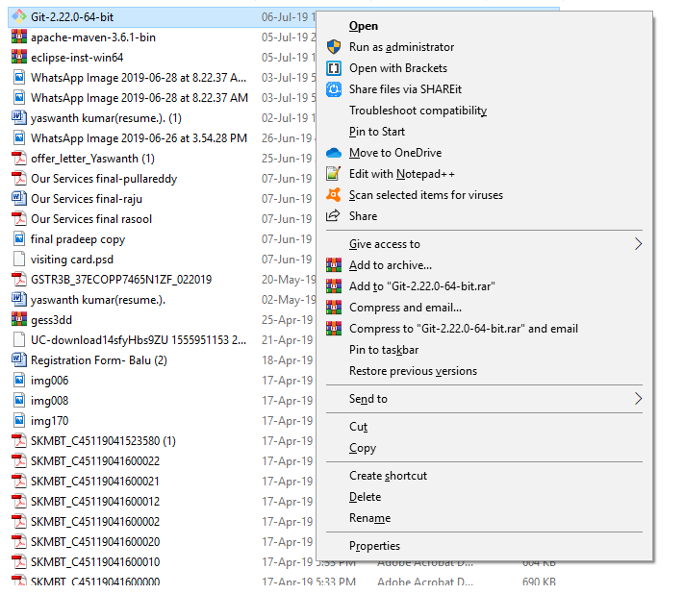

Click on yes button.

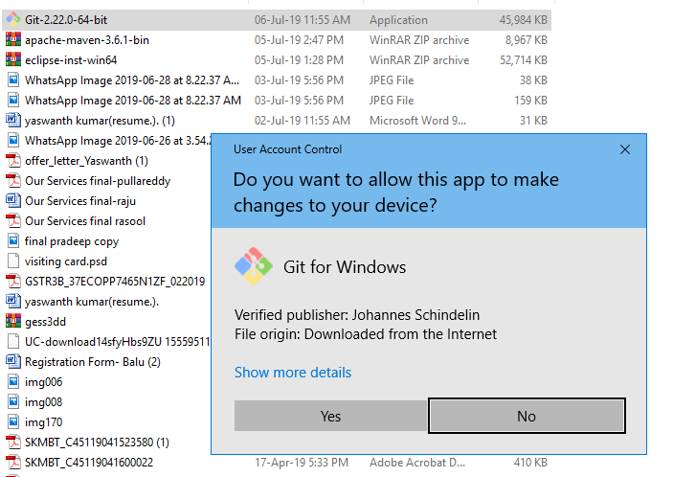

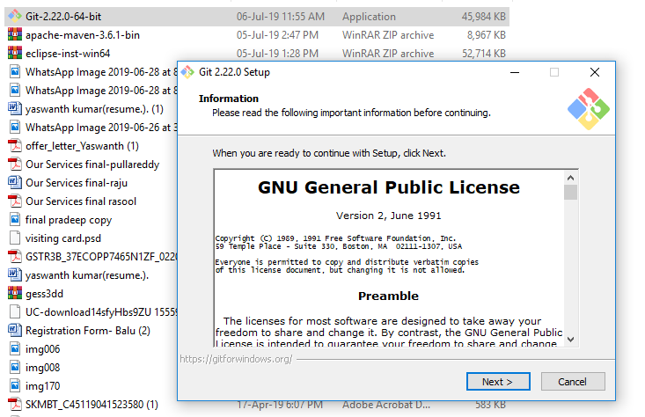

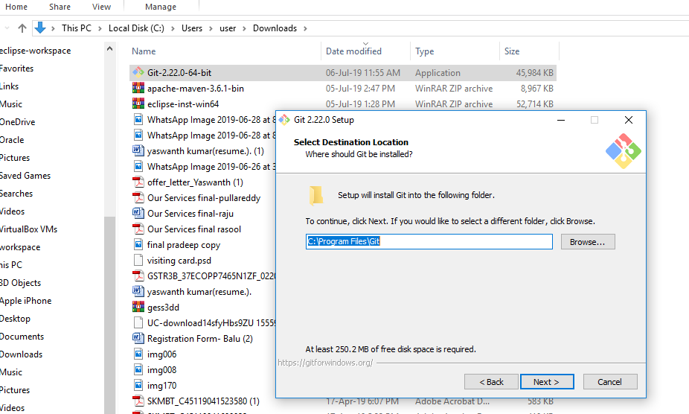As your wish to select location of git installation.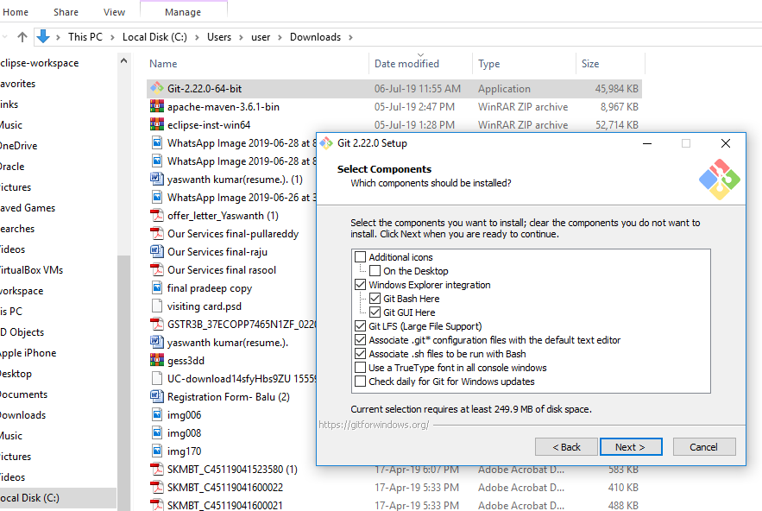

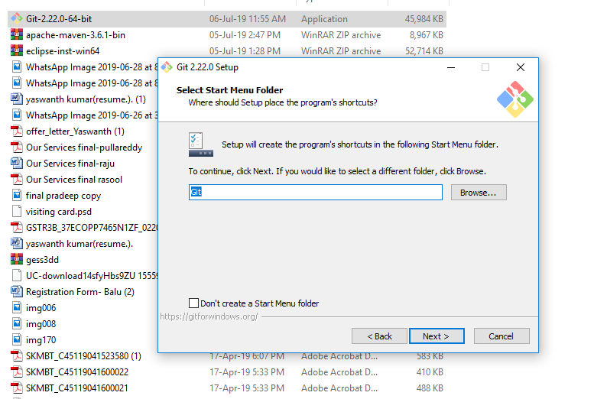

There is no modification is want just click next.

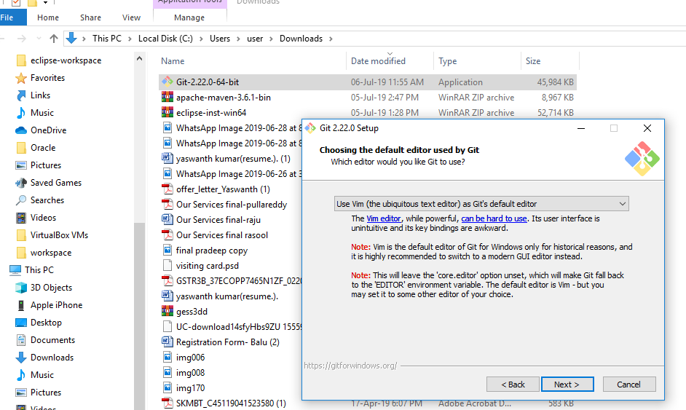

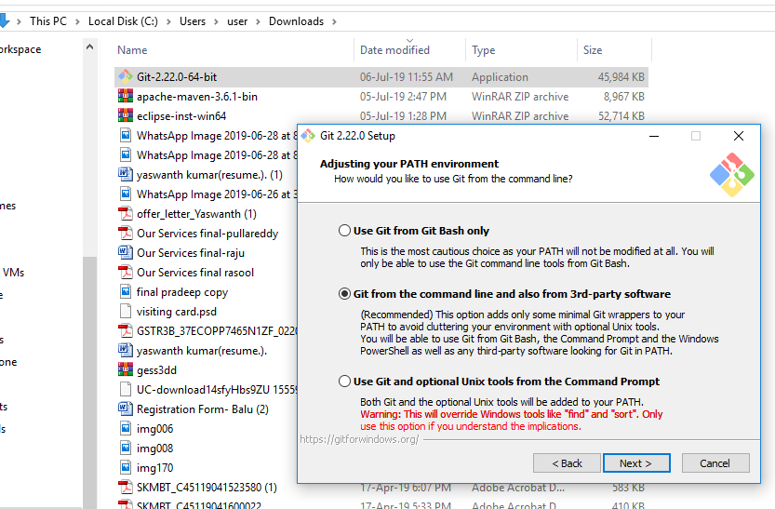

Click on next button,there is no modifications are required.

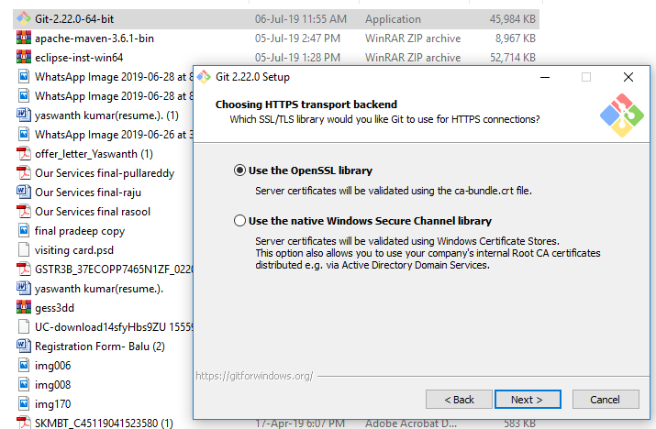

Click on next button of open ssl library.

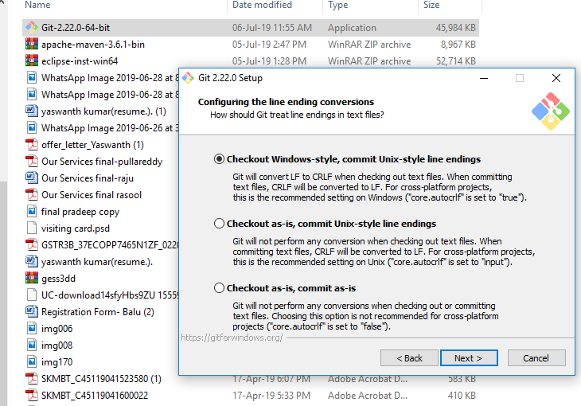

No modifications are required just click on next button.

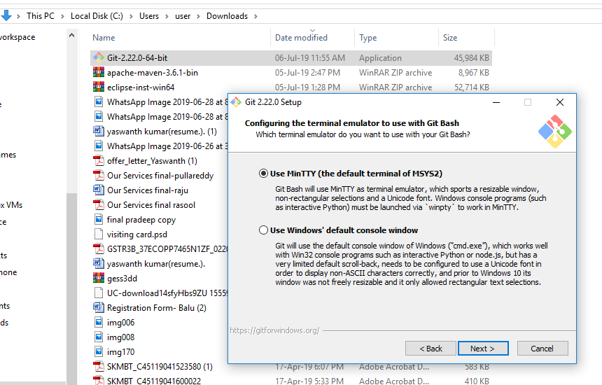

Click on next button here also no modifications are required.

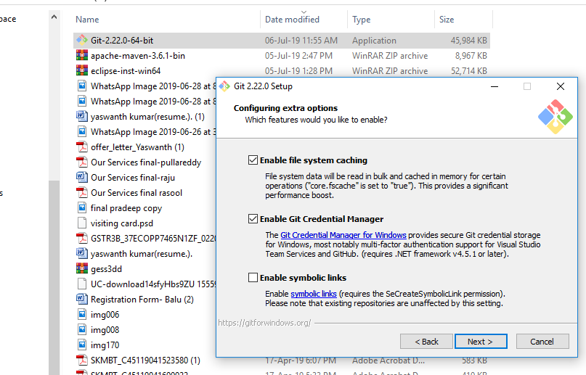

No modifications are required just click on next button.

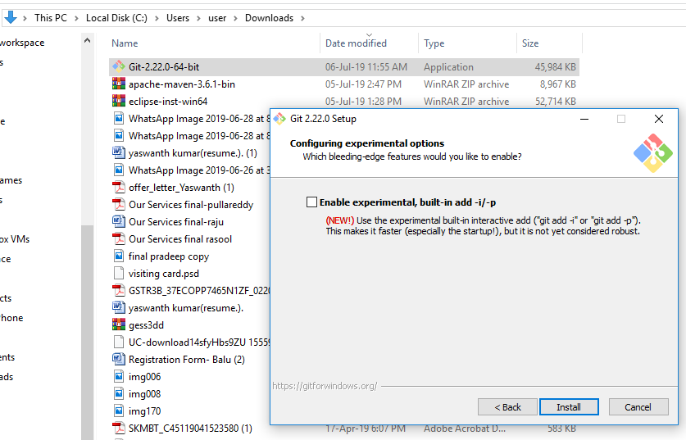

No modifications are required just click on install button.

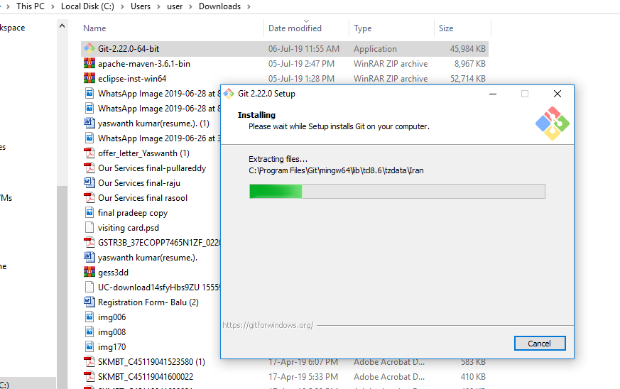

This is the installing process---

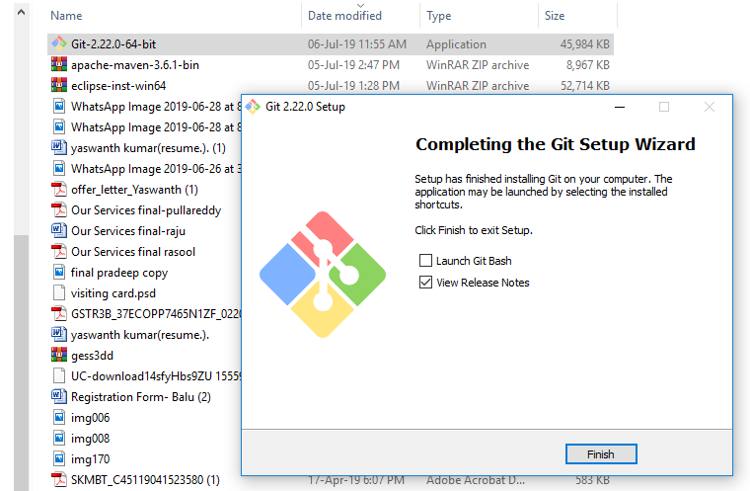

After installing click on finish button.

This is the process of GIT installation------

